Aim
Exercise 2: C Compiler in Virtual Machine

To install a C compiler (GCC) in the Linux VM and execute simple programs.

Procedure

Step 1: Open Terminal
In the Ubuntu VM, press Ctrl+Alt+T to open the terminal.

Step 2: Update Package Repository
sudo apt update

Step 3: Install Build Essentials
The build-essential package includes the GCC compiler and other necessary tools.
sudo apt install build-essential -y

Step 4: Verify Installation
gcc --version

Step 5: Write a Simple C Program
Create a file named hello.c using a text editor like nano:
nano hello.c
Enter the following code:
#include <stdio.h> int main() {
printf("Hello, Virtual Cloud World!\n"); return 0;
}

Step 6: Compile and Execute
gcc hello.c -o hello
./hello
Output should display: Hello, Virtual Cloud World!

Sample Program: Palindrome Check
A second program, palindrome.c, was written to check whether a given integer is a palindrome:

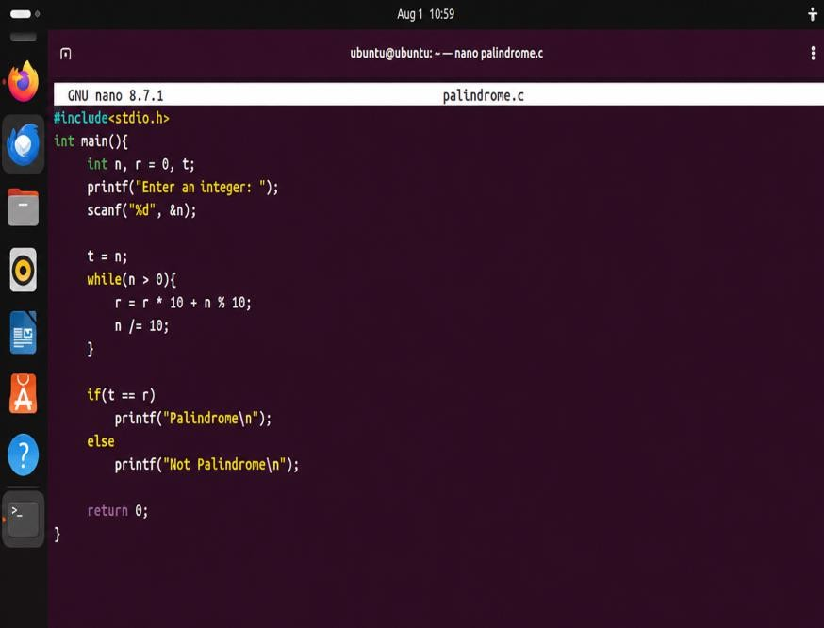

Output
The palindrome.c program was compiled and executed, and tested with two inputs (121 and 123):
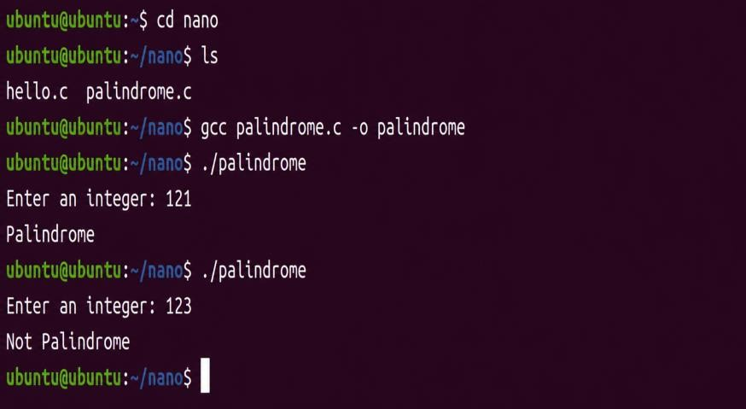

Result
Thus, the GCC compiler was successfully installed in the Linux VM and used to compile and run C programs.

